

|  |  |  |  |  |  |  |  |  |
| --- | --- | --- | --- | --- | --- | --- | --- | --- |
|  | | | | | | | | |
|  | | UEECS0003 & UEECS0022 | | | | |  | |
|  |  | | | | | | |  |
|  | | | |  |  | | | |
|  | | | | PRACTICAL ASSESSMENT #3: STUDENT NAME: Richard Pountney  STUDENT ID: 30007736 |  | | | |
|  | | | |  |  | | | |
|  | | |  | | |  | | |

# PART A: ASSEMBLE DESKTOP PC

All the parts

### 

### 

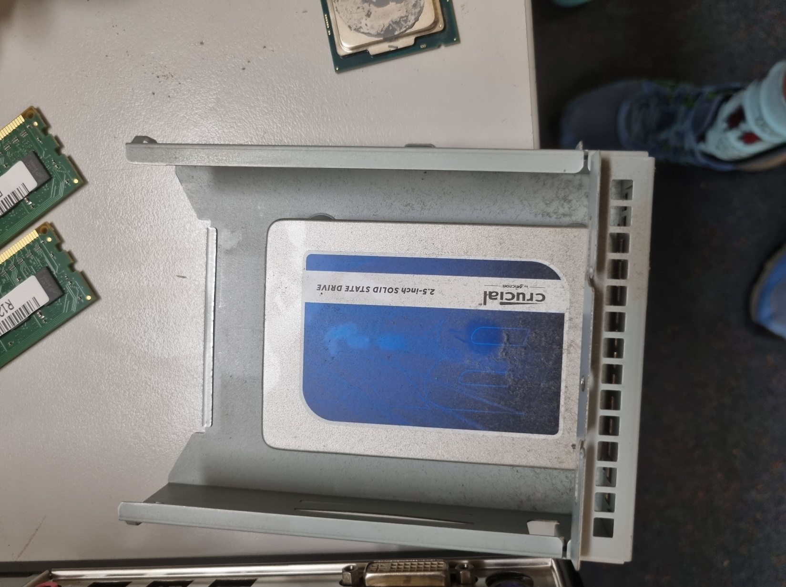

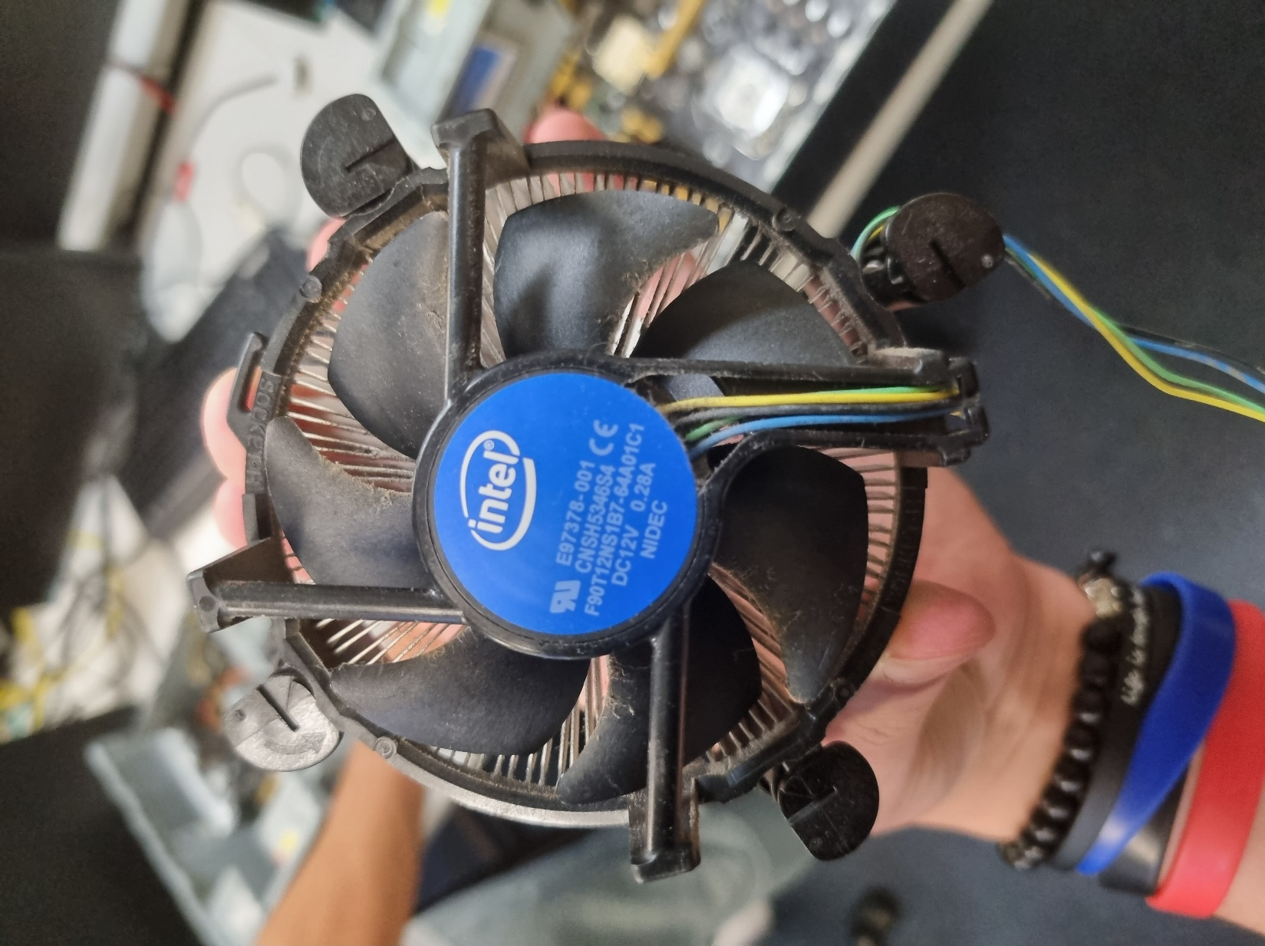

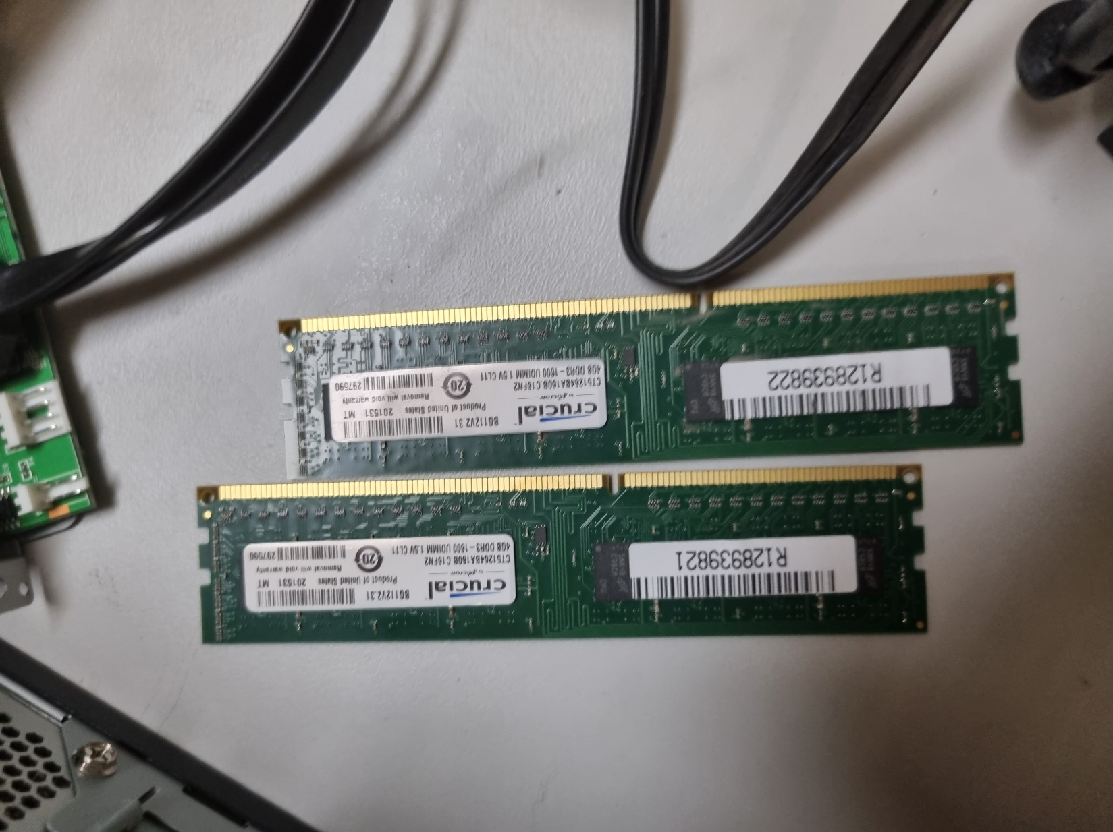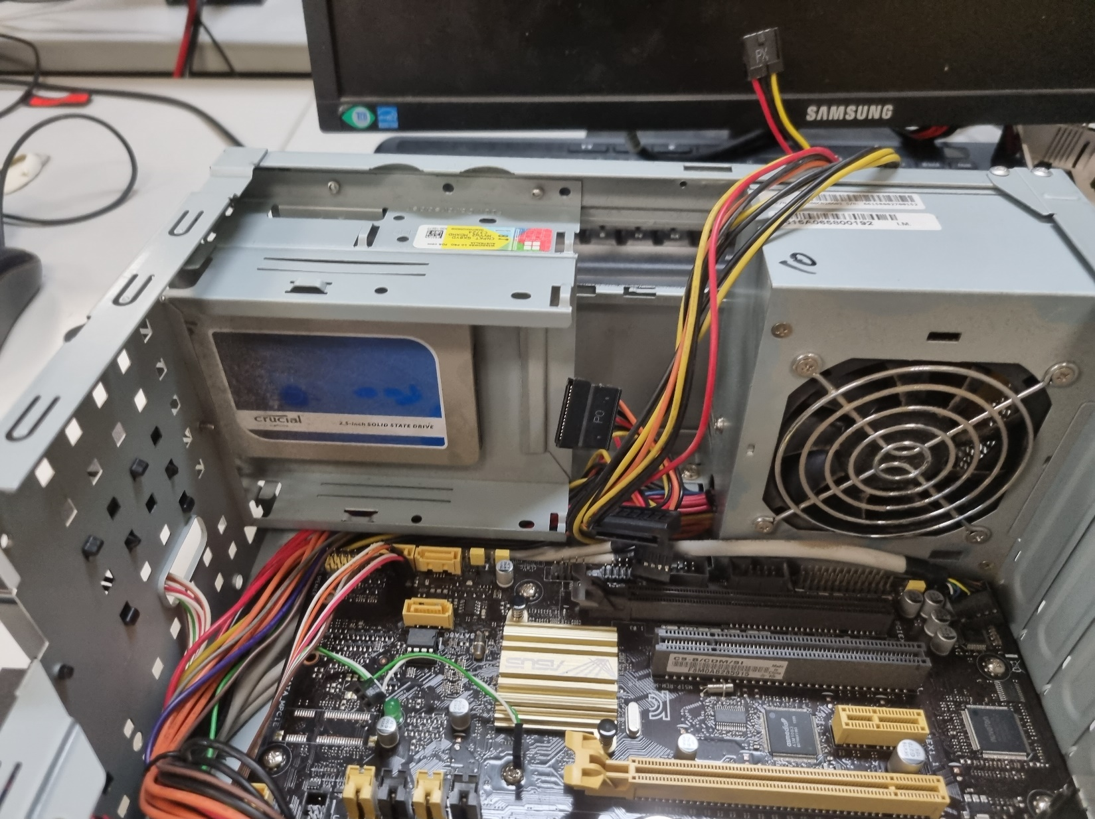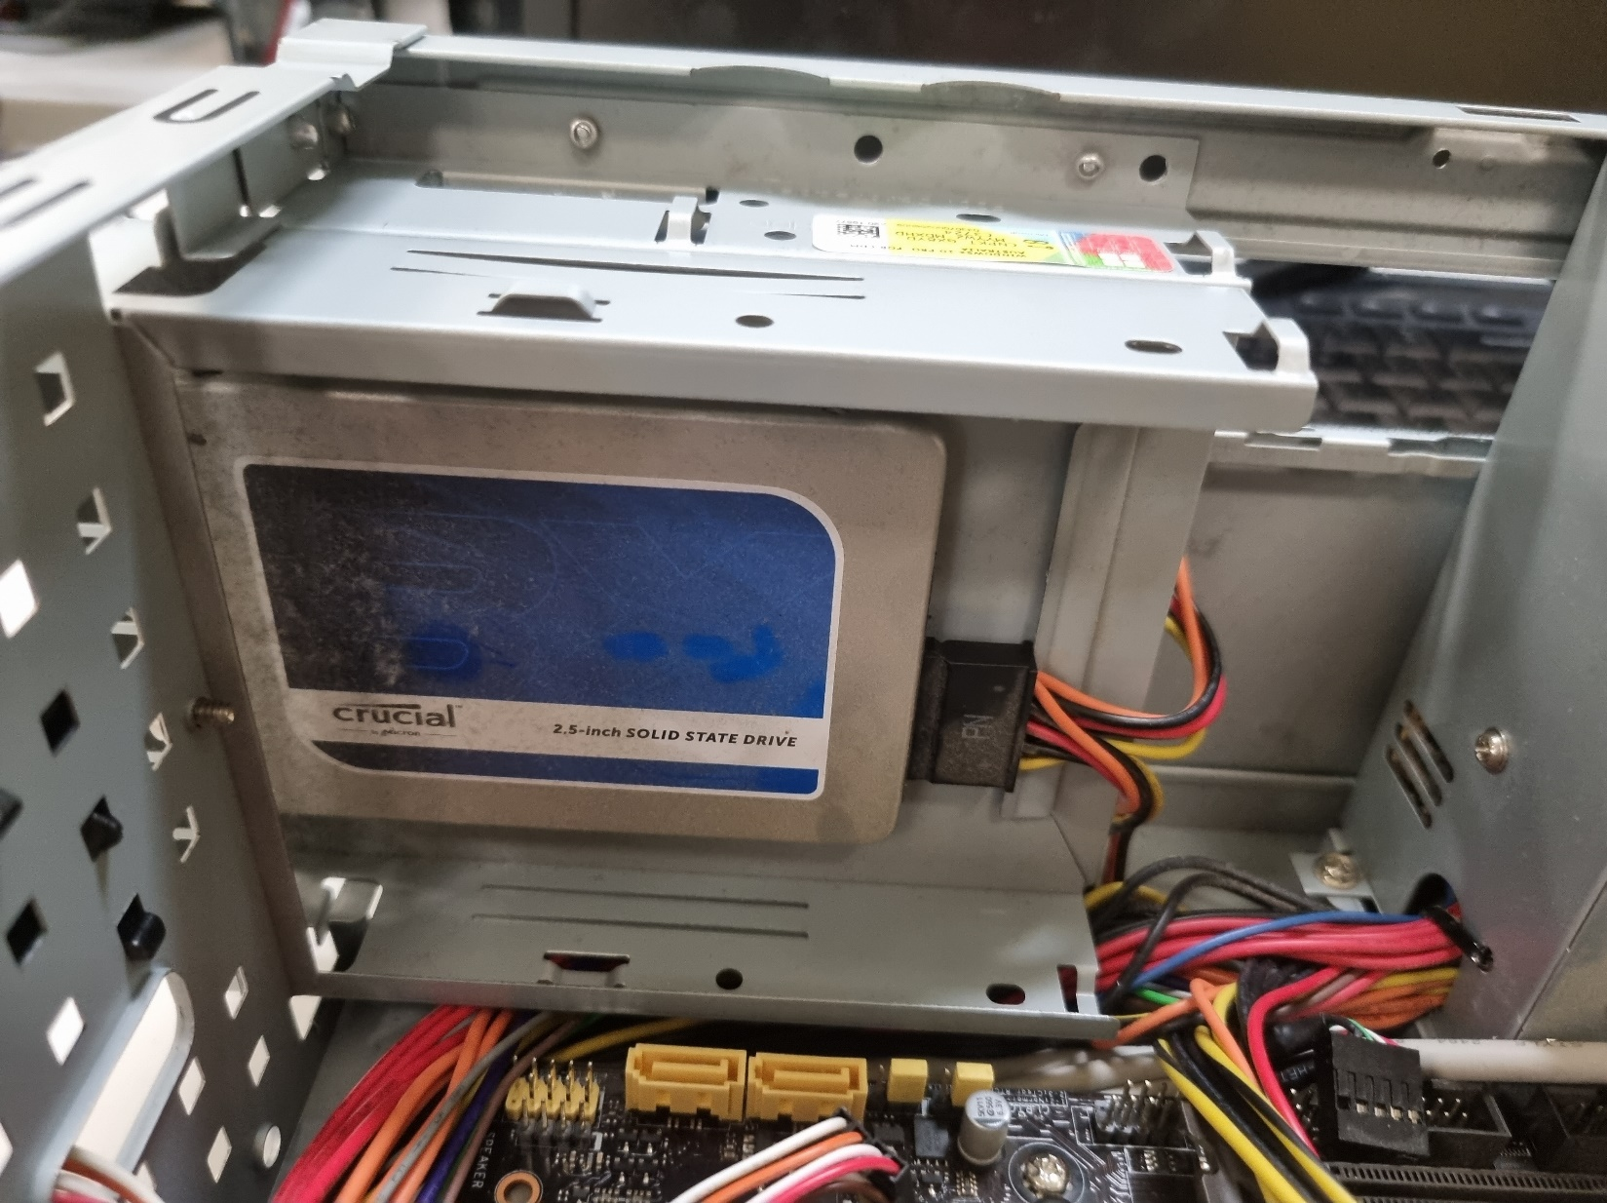

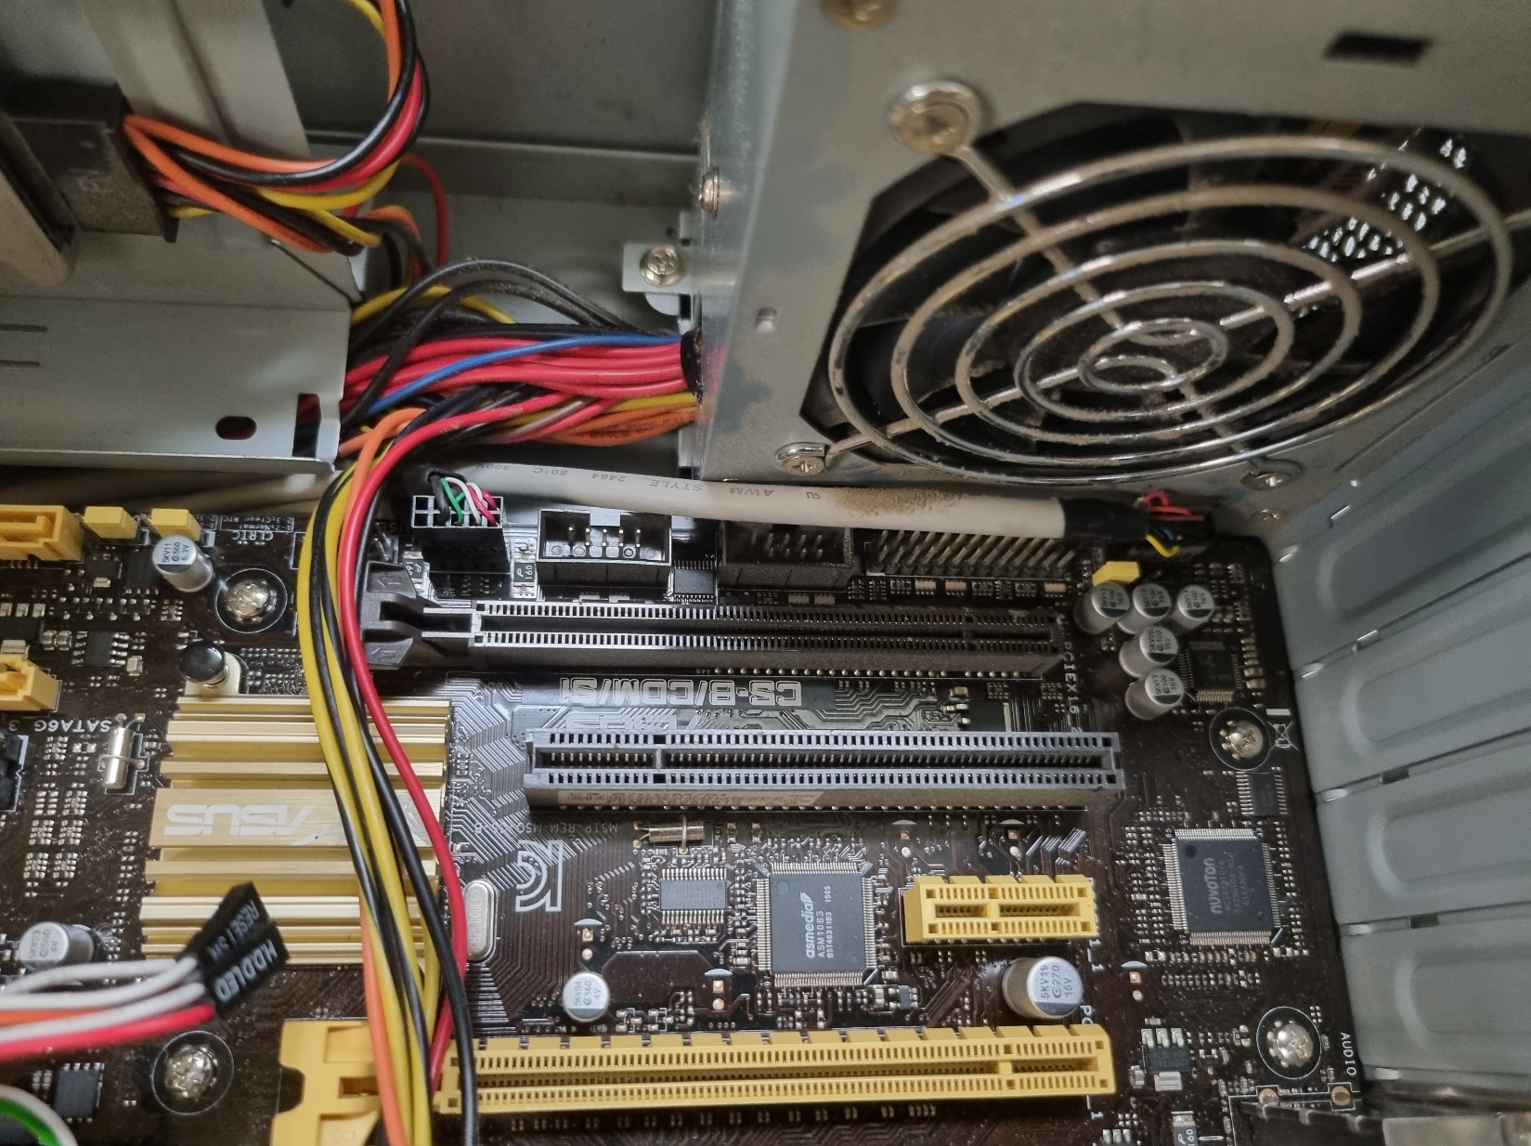

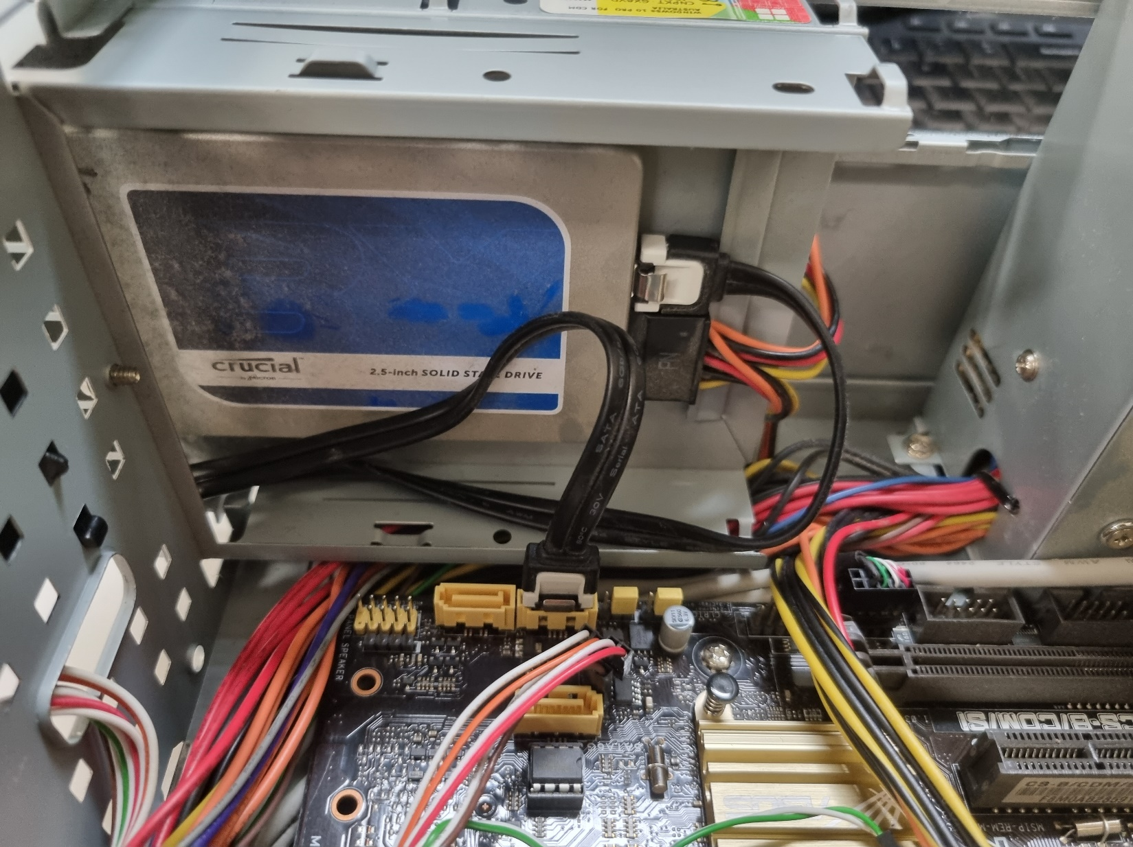

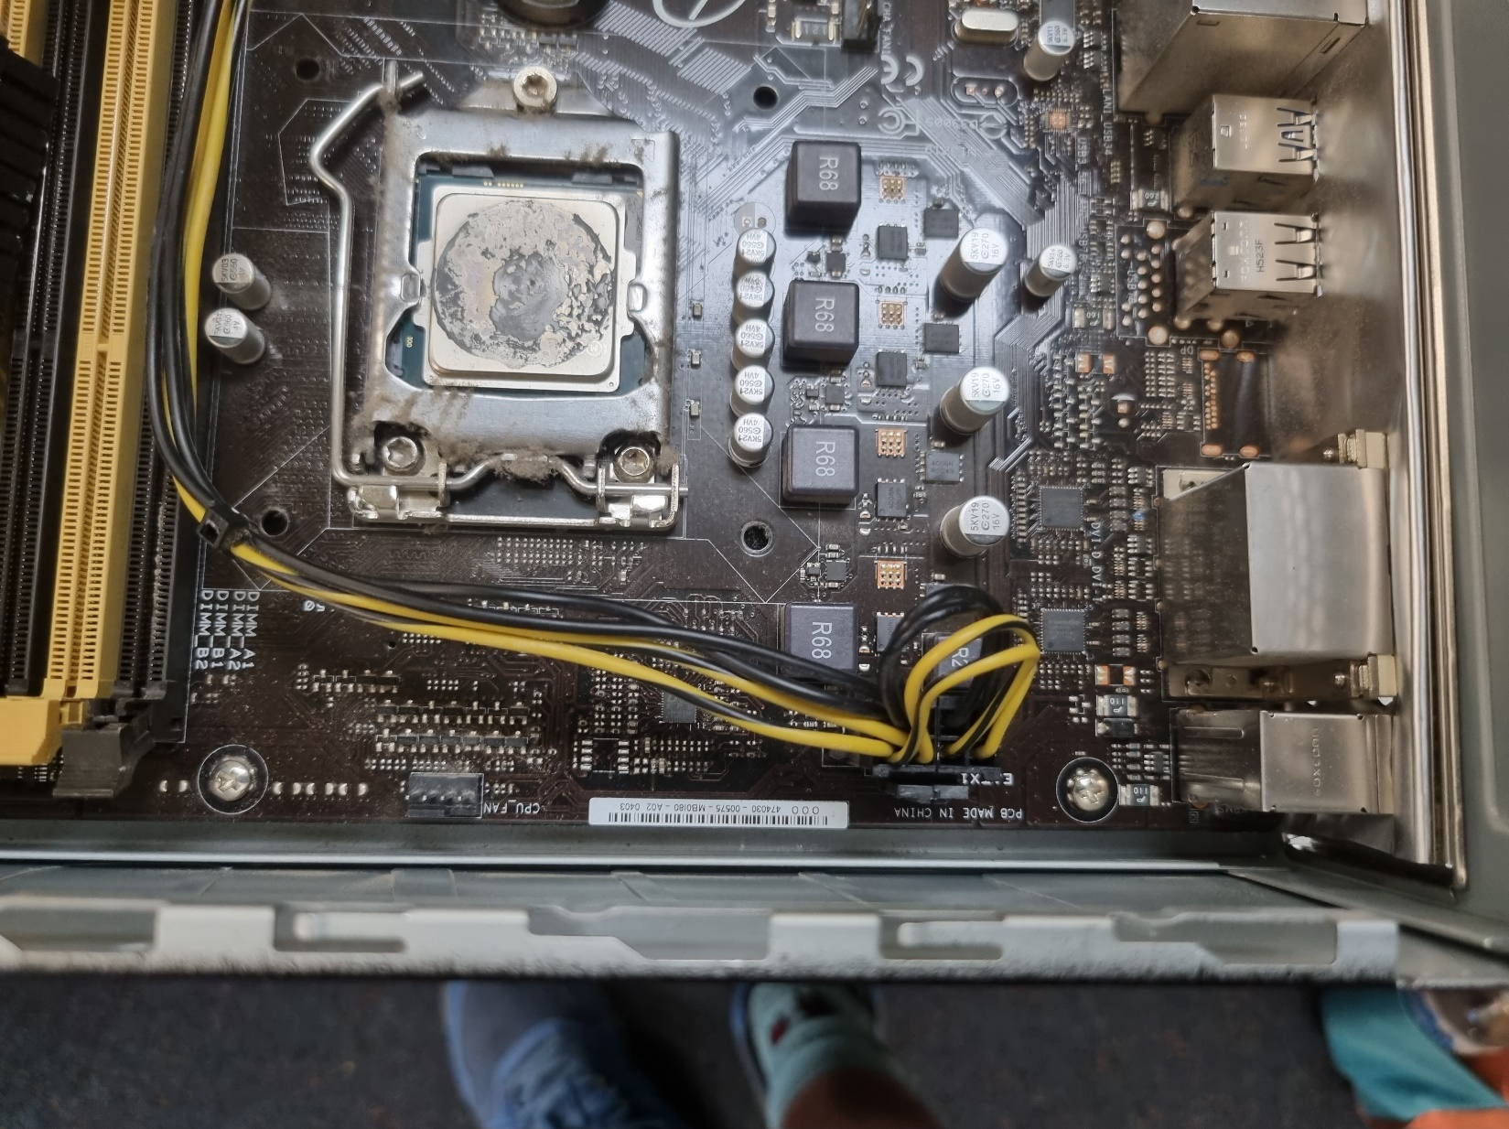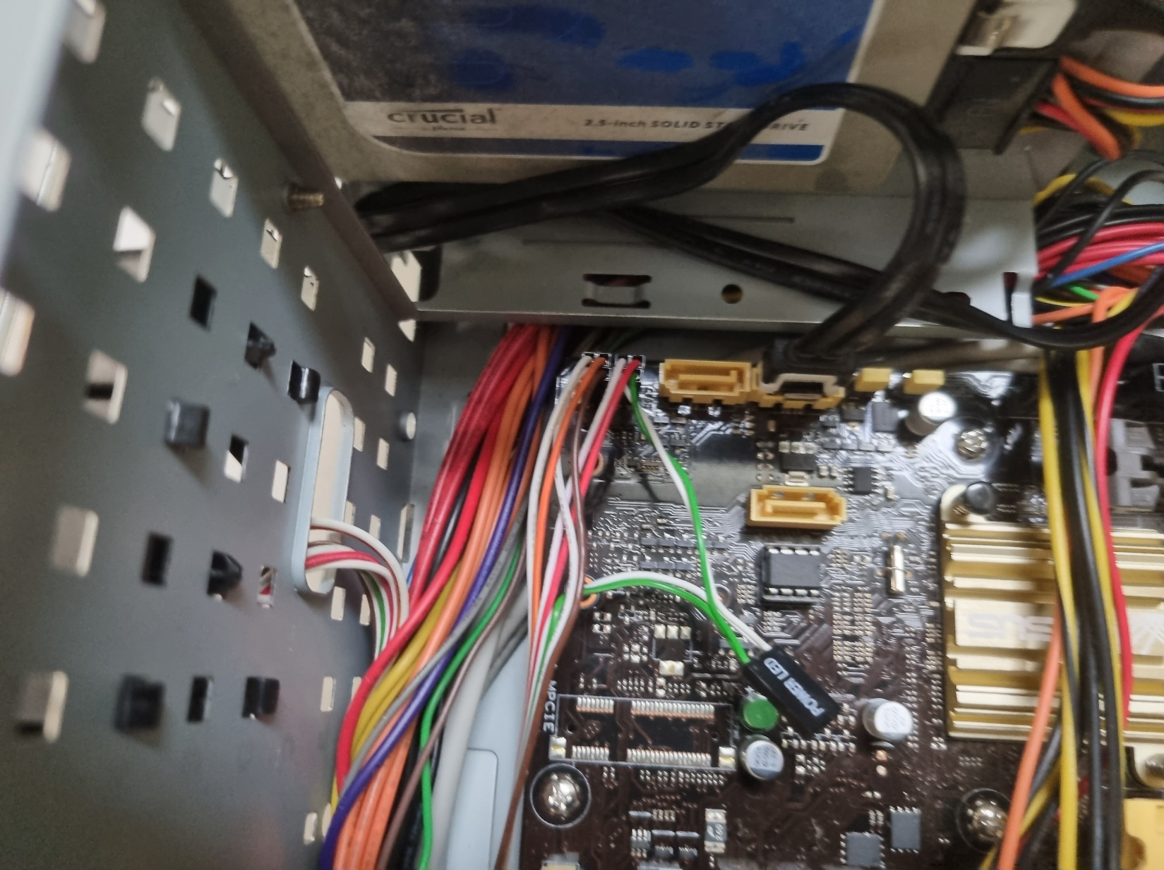

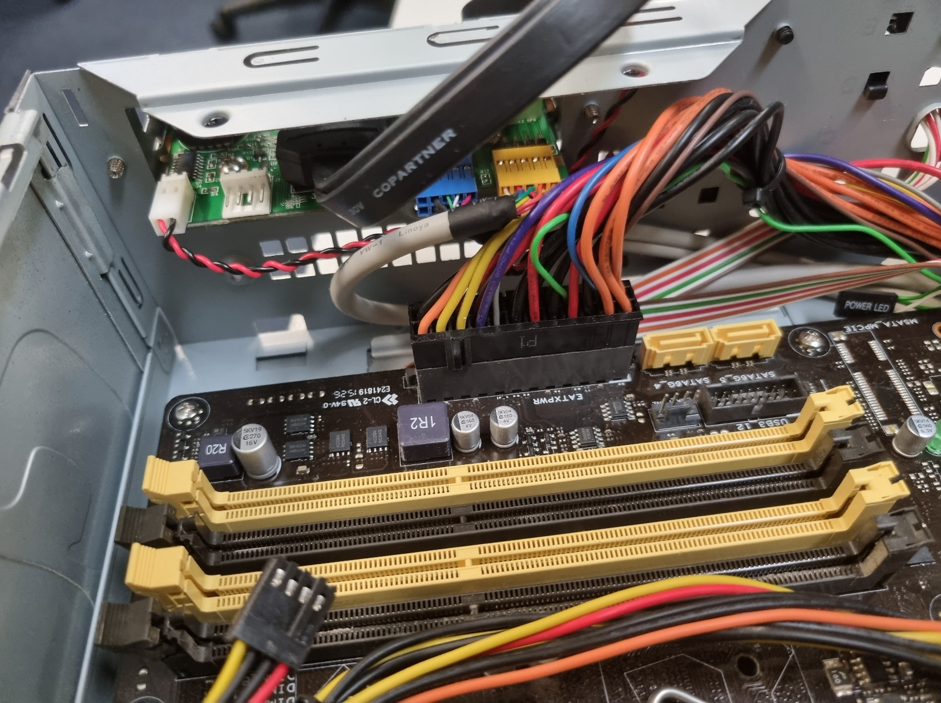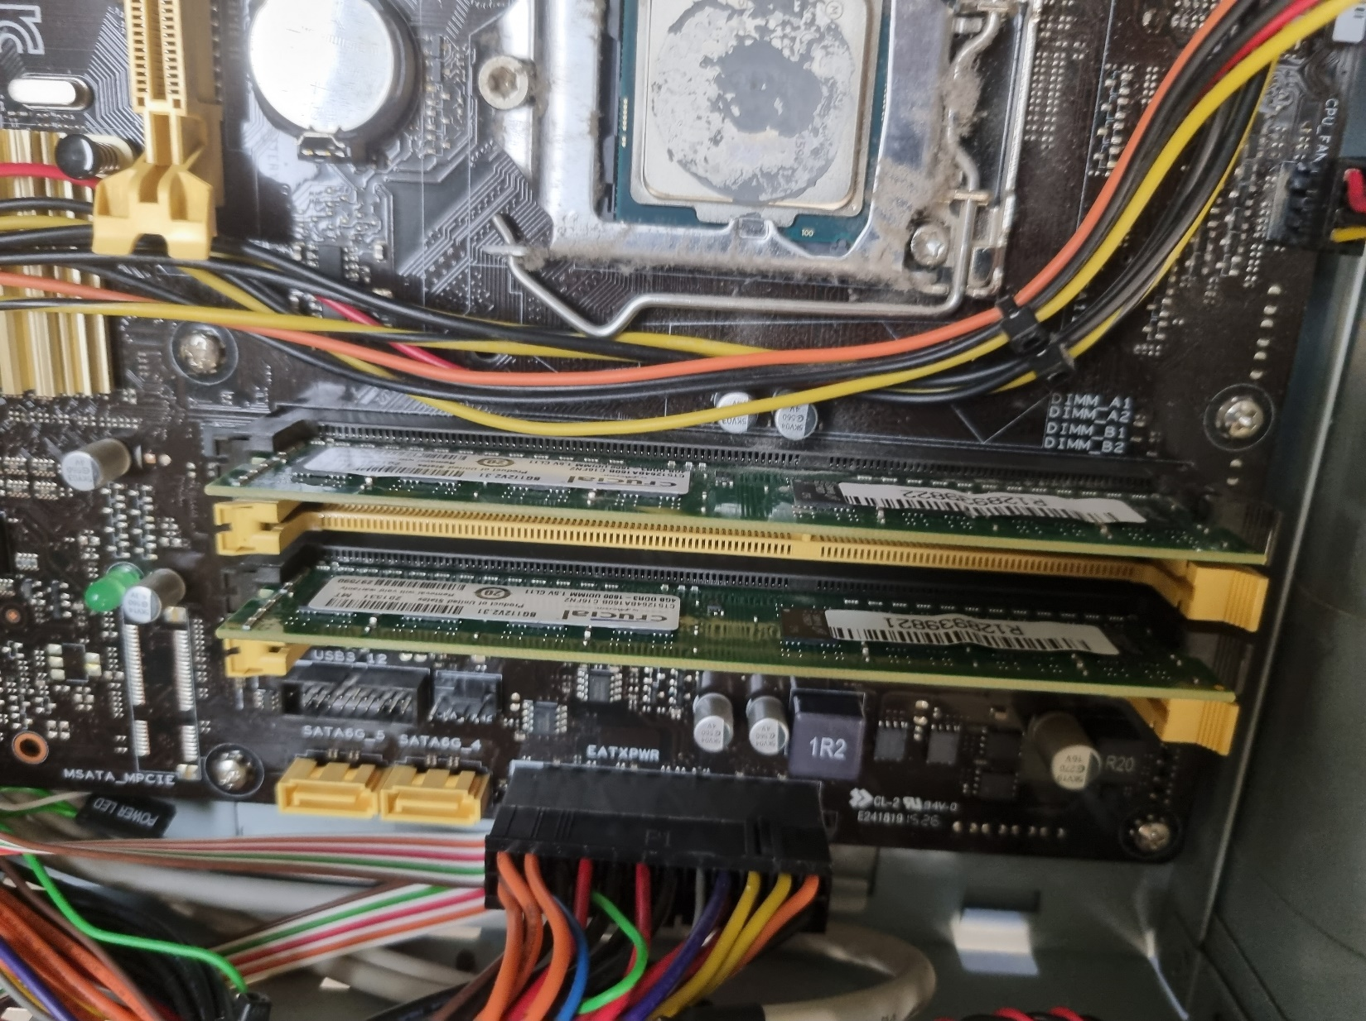

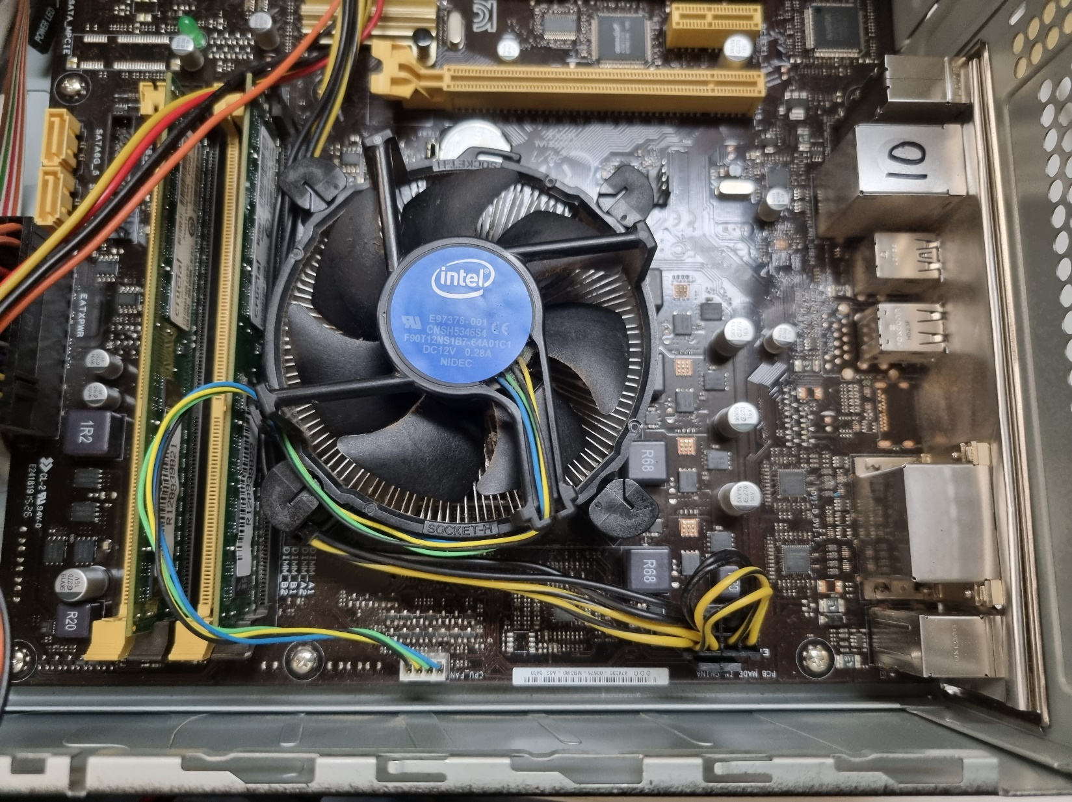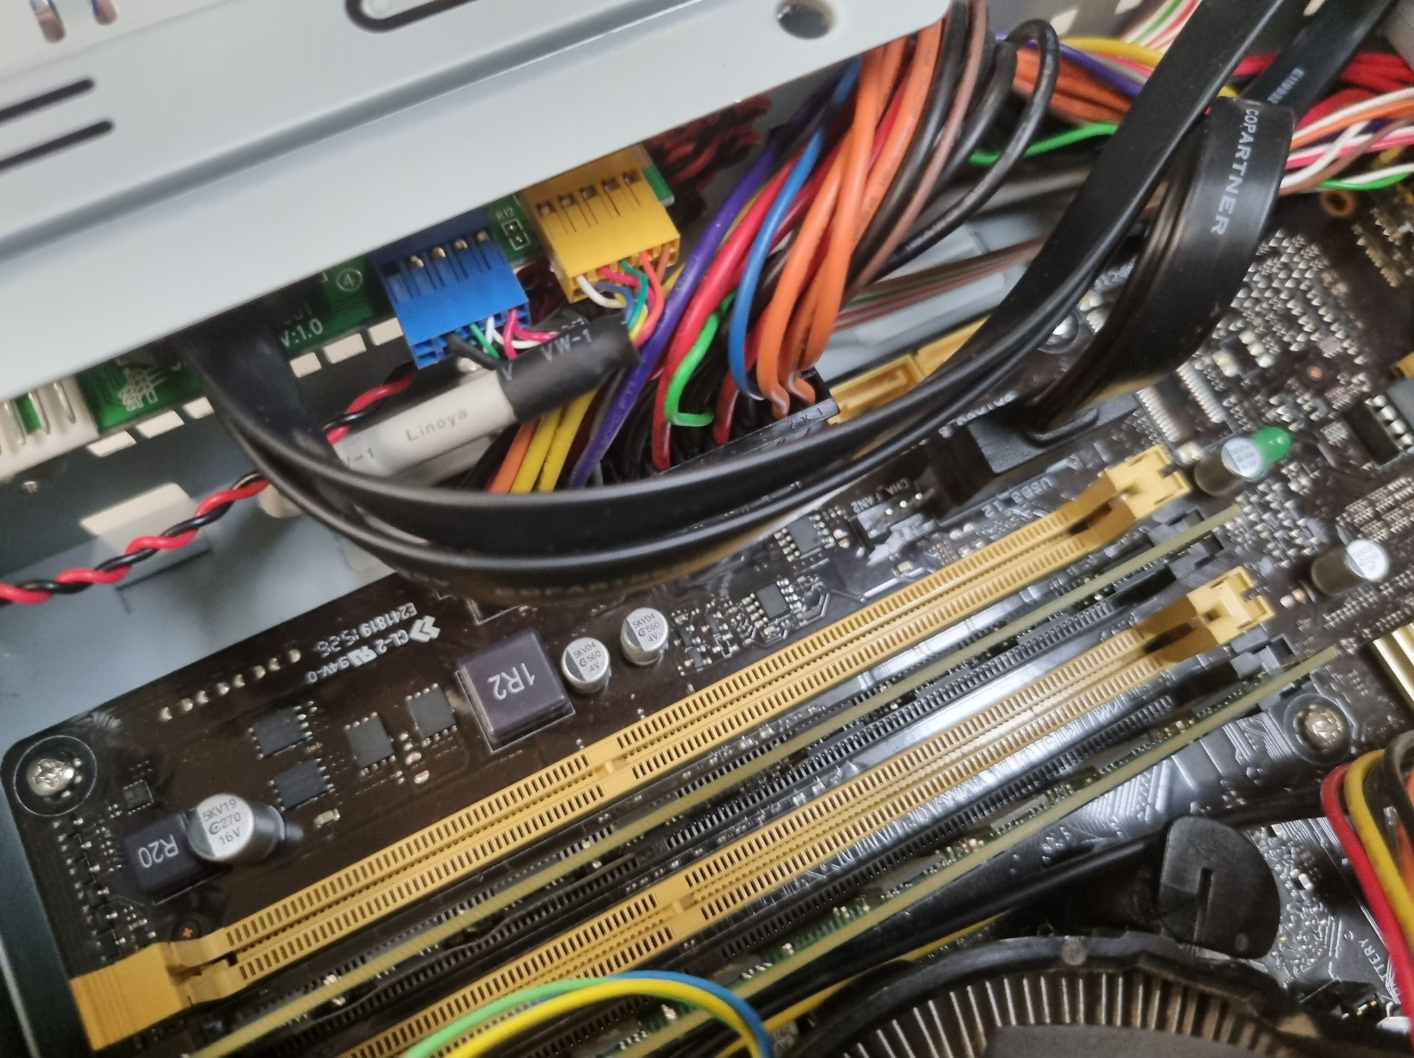

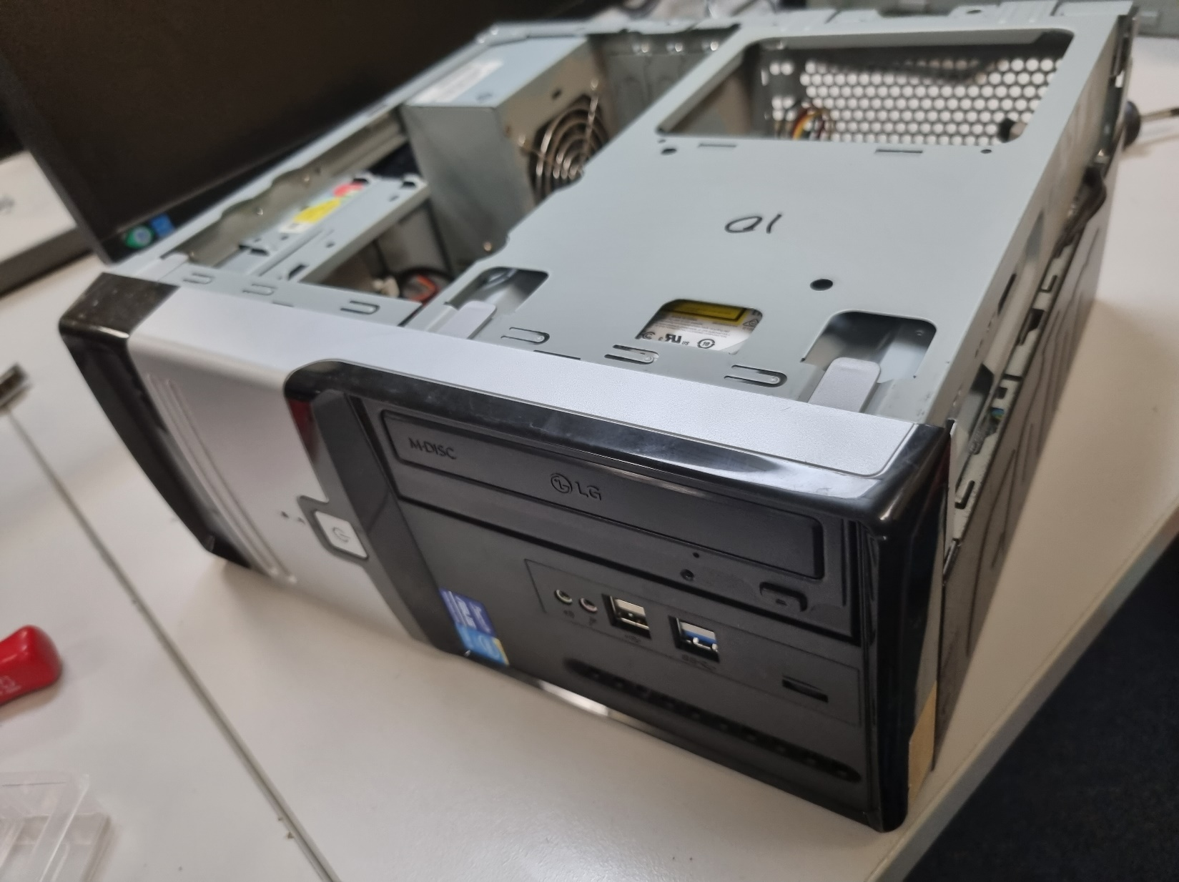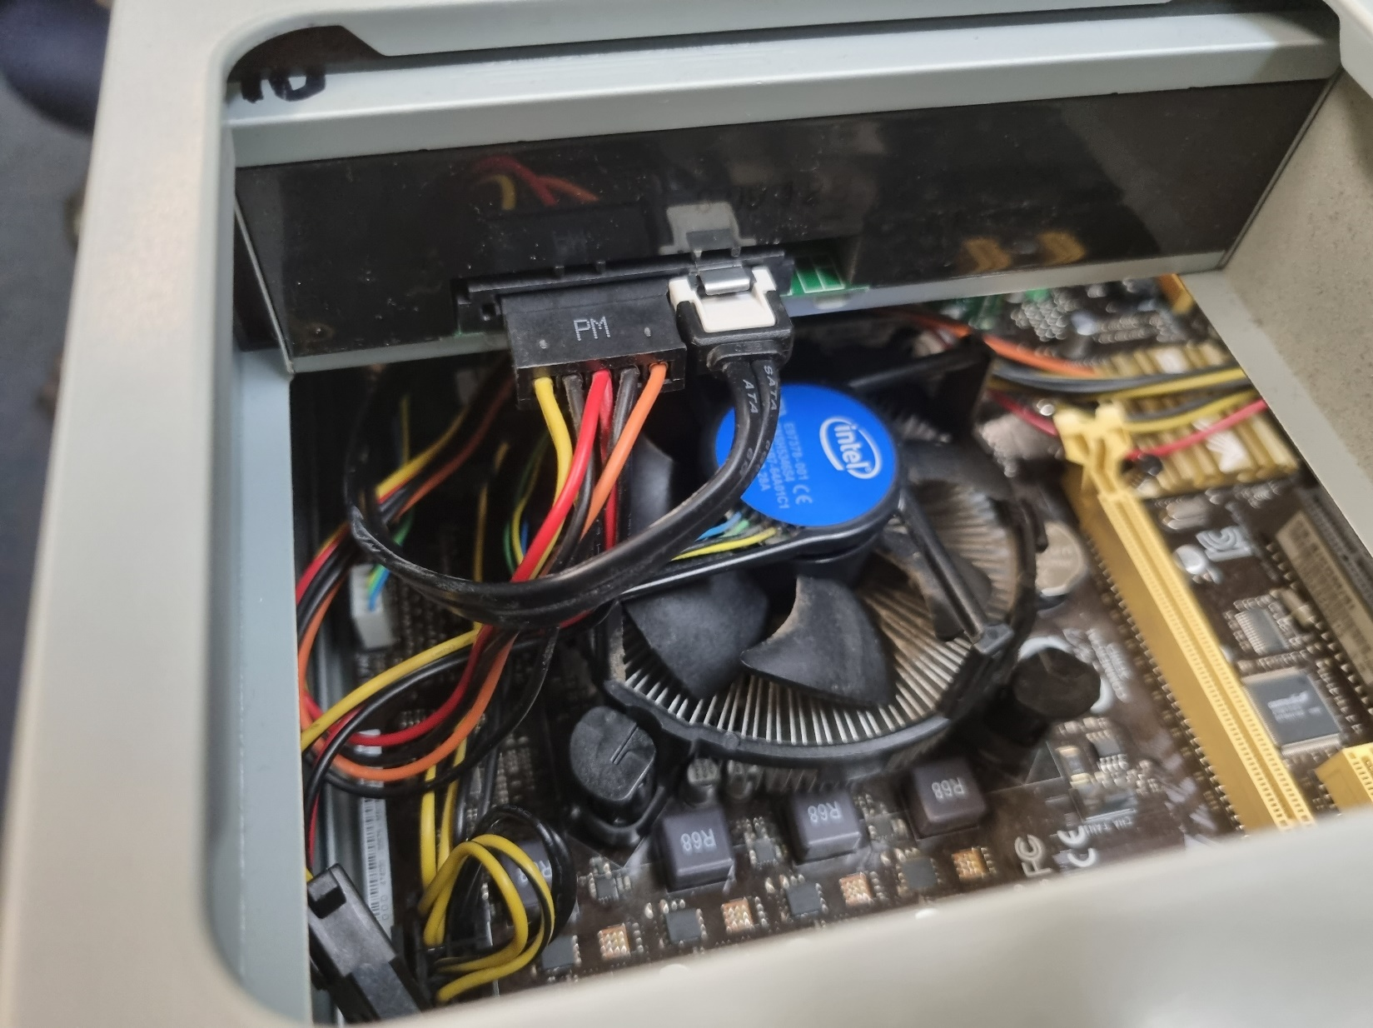

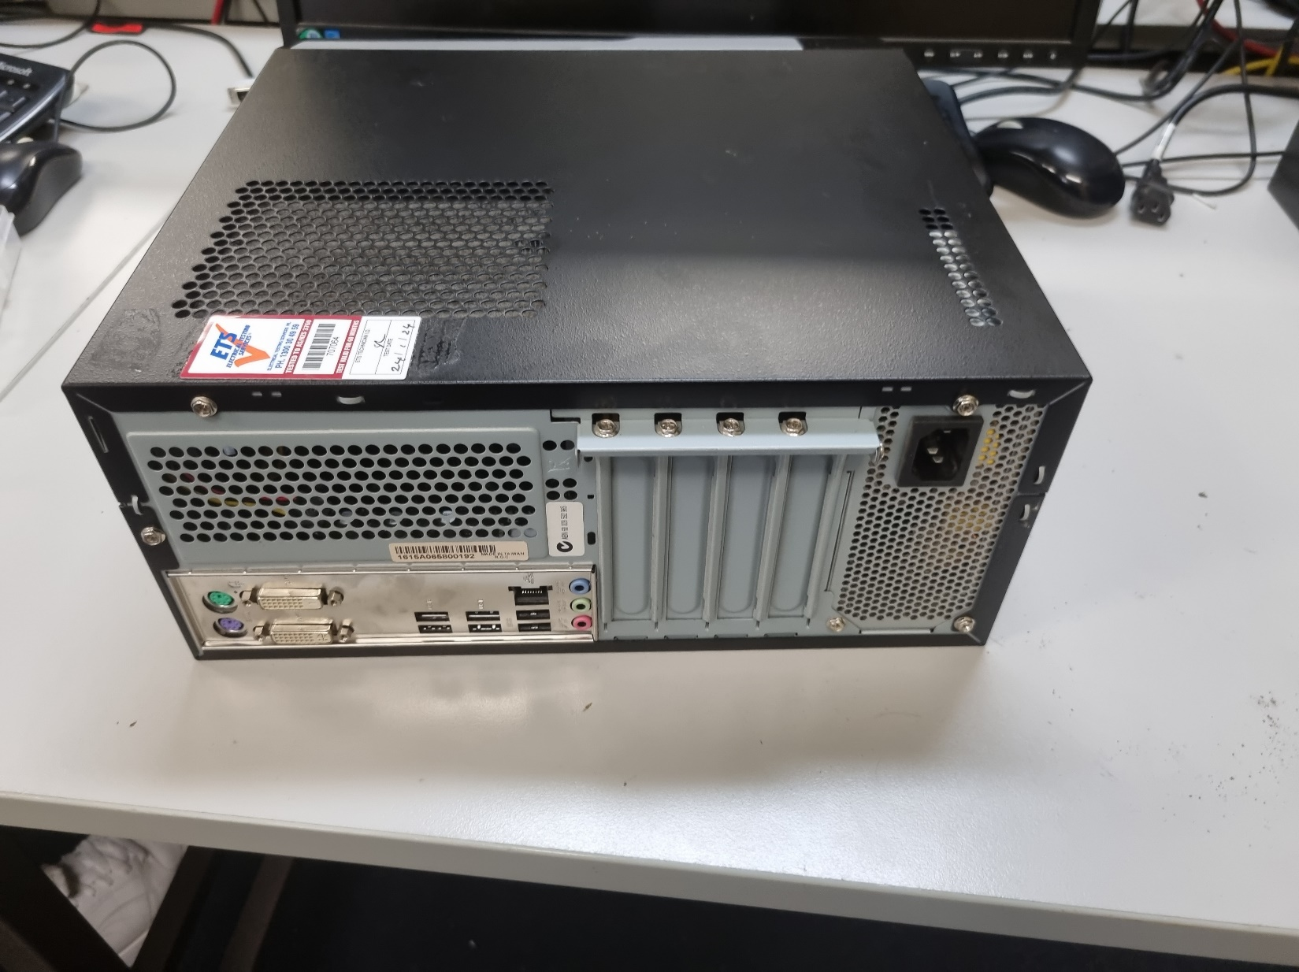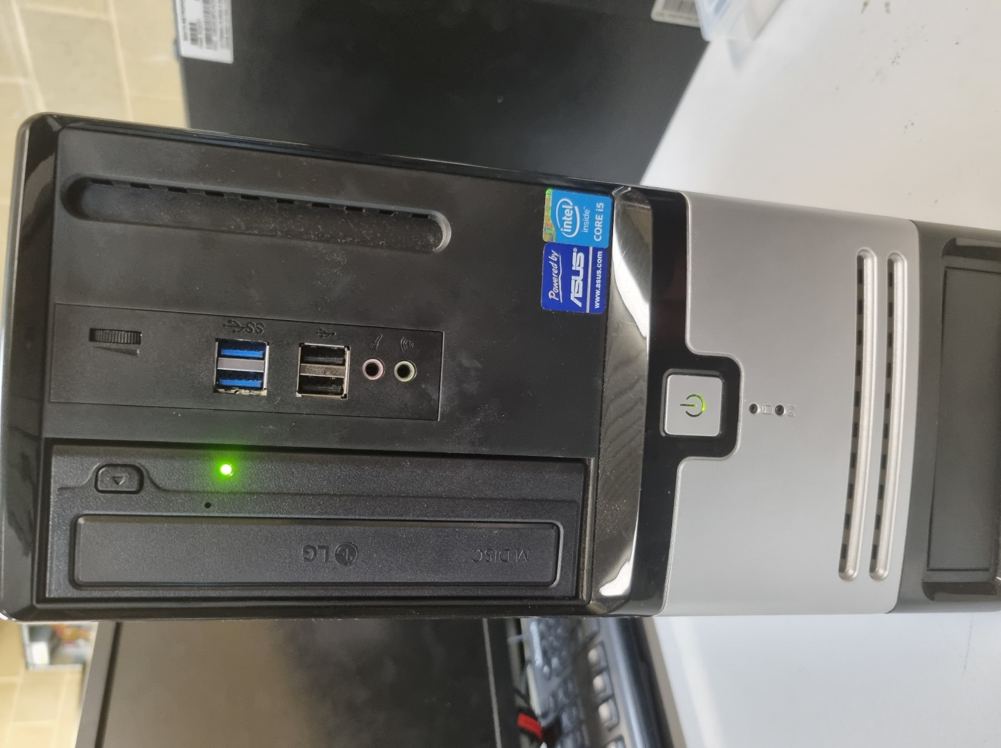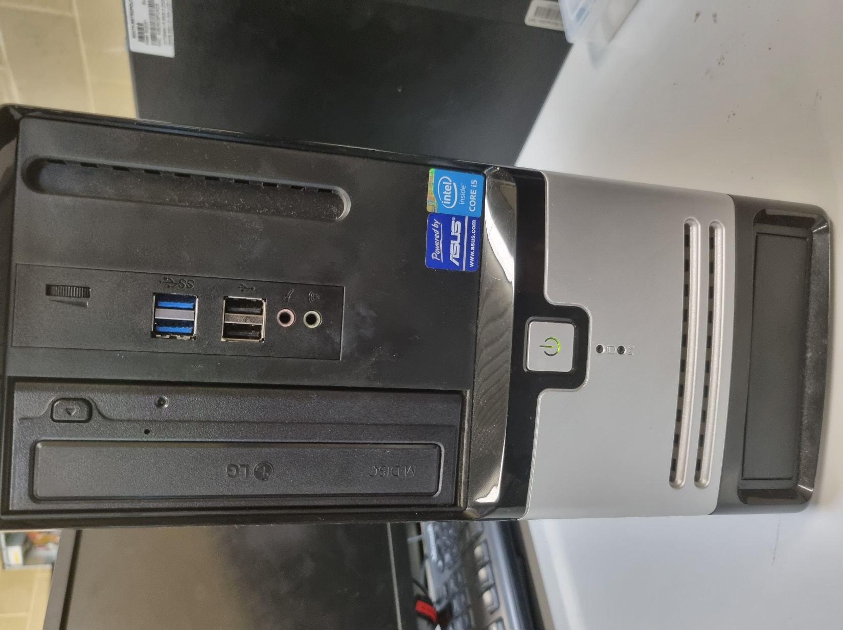

# PART B: BASIC PC TROUBLESHOOTING

### **Issue 1: "customer: I can connect to my WiFi network, but I can't access any websites."**

|  |  |  |
| --- | --- | --- |
| Causes | Solutions | Category (Hardware / Software) |
|  |  |  |
|  |  |  |
|  |  |  |

### **Issue 2**: **Customer Report: "My keyboard and mouse stop working randomly, and I have to restart my PC to get them working again."**

|  |  |  |
| --- | --- | --- |
| Causes | Solutions | Category (Hardware / Software) |
|  |  |  |
|  |  |  |
|  |  |  |

**Issue 3: Customer Report: "My computer says, 'Disk Boot Failure' when I try to start it."**

|  |  |  |
| --- | --- | --- |
| Causes | Solutions | Category (Hardware / Software) |
|  |  |  |
|  |  |  |
|  |  |  |

### **Issue 4: Customer Report: "My laptop gets super-hot after just a half-hour of use and then shuts down unexpectedly."**

|  |  |  |
| --- | --- | --- |
| Causes | Solutions | Category (Hardware / Software) |
|  |  |  |
|  |  |  |
|  |  |  |

### **Issue 5: Customer Report: "When I boot up my computer, the screen displays weird colors or sometimes just goes black."**

|  |  |  |
| --- | --- | --- |
| Causes | Solutions | Category (Hardware / Software) |
|  |  |  |
|  |  |  |
|  |  |  |

### **Issue 6: Customer Report: "I tried to upgrade my RAM, but now my computer won't boot and beeps continuously."**

|  |  |  |
| --- | --- | --- |
| Causes | Solutions | Category (Hardware / Software) |
|  |  |  |
|  |  |  |
|  |  |  |

### **Issue 7: Customer Report: "I tried to update to the latest version of the operating system, but now it's stuck in a loop and won't start up."**

|  |  |  |
| --- | --- | --- |
| Causes | Solutions | Category (Hardware / Software) |
|  |  |  |
|  |  |  |
|  |  |  |

### **Issue 8: Customer Report: "There's a loud grinding noise coming from my computer tower."**

|  |  |  |
| --- | --- | --- |
| Causes | Solutions | Category (Hardware / Software) |
|  |  |  |
|  |  |  |
|  |  |  |

# PART C: INSTALL AND TEST OPERATING SYSTEM

# PART D: SETUP BASIC PC NETWORK

|  |  |  |  |  |
| --- | --- | --- | --- | --- |
| PC | LAN | IP address | Subnet | Default Gateway |
| PC0 | LAN1 | 192.168.1.100 | 255.255.255.0 | 192.168.1.1 |
| PC1 | LAN1 | 192.168.1.101 | 255.255.255.0 | 192.168.1.1 |
| PC2 | LAN2 | 192.168.2.100 | 255.255.255.0 | 192.168.2.1 |
| PC3 | LAN2 | 192.168.2.101 | 255.255.255.0 | 192.168.2.1 |